Extreme Makeover for Counselors in Private Practice
Submitted by:
Viviane Ephraimson-Abt
Valerie Lorig
Faith Brandt
Biljana Gibarac
December 6, 2010

Section I: Introduction
Where do private practice counselors learn the skills to run a successful business? Building business skills for counselors is not given much attention in graduate school education. In a review of the Council of the Accreditation of Counseling and Related Educational Programs (CACREP) 2009 standards, business management is not included as a specific competency and the word business is only used three times in the 63 page document. Embedded in the CACREP standards are that counselors will learn professional skills through practicum and internship and through professional development at work and in their professional associations.
What does a professional organization offer for building business skills? A review of the American Counseling Association (ACA) web site revealed that one page is dedicated to private practice resources, many out dated. One resource suggested that new private practice therapists get a phone number, answering machine, and pager (Walsh & Dasenbrook 2005). Of the 24 podcasts posted on the ACA website, only one was focused on setting up private practice (Walsh, & Dasenbrook 2008). The ACA’s monthly magazine does have column dedicated to questions about private practice and these are posted to the website. Overall, the ACA suggests that private practice counselors are entrepreneurs who need skills and information to be successful. Yet, while the ACA offers extensive information on counseling methods and client issues, it has limited entrepreneurial resources for private practice counselors.
Why is this so? Part of this might be in the professional culture of counselors themselves. Lyn Grodski, a psychotherapist and author of four books on practice building, writes that counselors “wrestle with the question of whether psychotherapy is a vocation or an occupation. Is what we do a service (i.e. helping others) or a business (i.e. filling the needs of others for a profit)?” (Grodski 2007, p. 28). Joe Bavonese, a psychologist and business coach for counselors writes about “the blinders that all therapists unconsciously wear, for example, assuming our clinical skill is all we need to succeed” (Bavonese 2007, p.35). In his experience, therapists often experience a great deal of tension between being of service and investing in the self-promotion required to strengthen or grow their business. The 70 therapists he polled in 2007 were only willing to spend $83.00, on average, to generate 12 new referrals a year, which could have yielded $12,000 in income. Yet, these same therapists reported spending thousands of dollars annually to attend clinical trainings (Bavonese 2007, p. 37).
Private practice counselor’s today are faced with a rapidly changing environment which requires a business mindset. This paper will explore some of these rapid changes and will consider some of the skills and knowledge needed to navigate this environment. This paper will cover the ways in which counselors are defining their practices, diversifying their services and streams of income, and expanding their use of technology. The most current information on these issues is based primarily in internet and professional resources.
Section II: Why Brand and Diversify A Private Practice?

In 1997, Lynn Grodzki began working as a business coach for therapists. Initially her coaching clients were primarily new therapists, but in 2003 a growing number of senior, well-established therapists began contacting her for help. They were struggling to find new clients and to pay their bills. In the July/August 2007 edition of the Psychotherapy Networker, Grodzki sites several reasons for the senior therapists’ struggles. Managed care reimbursements had not risen for a decade, mental health insurance coverage was declining, and the self-pay mental health client market was eroding. Alternative health care, the self-help market, and psycho-medication appeared to be attracting clients away from entering counseling. According to Grodzki (2007) these changes required that psychotherapists make a paradigm shift and give up their dependency on the medical model and managed care as their main referral source and respond to market conditions as a business professional. Therapists were being called to:
“learn to face the public squarely on footing equal to that of other service-oriented professionals and find the words to explain, who we are, what we do, and why psychotherapy is important…being a small business allows us to be flexible, respond to feedback, and routinely measure client results in order to create practices that follow consumer needs and desires.” (Grodzki 2007, p. 28)
In the March/April 2009 issue of Psychotherapy Networker, Grodzki wrote on some of the most current ideas for strengthening a private practice in a recession economy. Her first suggestion is to learn what services are essential for clients. In her research these include psychological services for children (i.e. ADD, autism spectrum, high risk teens), marriage or relationship savers (i.e. divorce prevention, financial counseling), career savers (i.e. anger management, addictions) and health related services (cancer, stress, anxiety reduction).
Grodzki, (2009) also suggests that therapists consider their greatest strengths and what is in most demand, and invest their efforts and their resources in that direction. This includes reducing activities in their practice that do not result in expanding your client network or that are unprofitable. This can also include adding certain aspects to a practice like taking credit card payments, reduced prices on therapy packages, having additional office locations to broaden client base, developing a workshop or products to create more points of service, etc. Doing these things can help a therapist develop a Unique Selling Point (USP) to brand their services and increase their ability to clearly differentiate their practice for therapy consumers. Here is an example of a USP:
“I offer short-term counseling for couples with long-term results. Whether couples want help fixing their marriages or better parenting their children, we move forward on their goals quickly. My practice offers a variety of services, pricing packages and locations in which I can see you. I strive to stay flexible so we can work together successfully, even during these tough economic times.” This therapist’s business card reinforced her message with the slogan, “short-term counseling for couples with long term results.” (Grodzki, 2009, p.38)
Section III: A Diverse Package of Services
Today’s workplace requires diversifying one’s skills and knowledge. Creating a career that utilizes an individual’s unique gifts and talents requires thinking outside-the-box. Career experts stress the importance of “nurturing passions, identifying potential and honoring courage...” (Feller & Whichard, p.123-24). In order to succeed in today’s marketplace; counselors, therapists, and mental health practitioners need to utilize their talents in a variety of ways. This section explores how counselors can promote themselves and expand their skills beyond the office. David Diana, author of Marketing for the Mental Health Professional says:
A key area most mental health practitioners are sorely lacking in is the understanding and use of sophisticated sales and marketing skills. Clinicians receive heavy doses of clinical training in graduate schools…however very little is offered in terms of how to succeed in the profession from both a financial and career development perspective…Understand that you are involved in sales and marketing regardless of your profession. (2010, p.7))
Understanding resources and using them to one’s advantage is key. Traditional resources, such as brochures, print ads or radio are still valuable when used cost effectively however, a host of additional paradigms have proven successful. The following chart shows six areas therapists can expand their practice, market their skills, utilize their talents, and diversify their income.
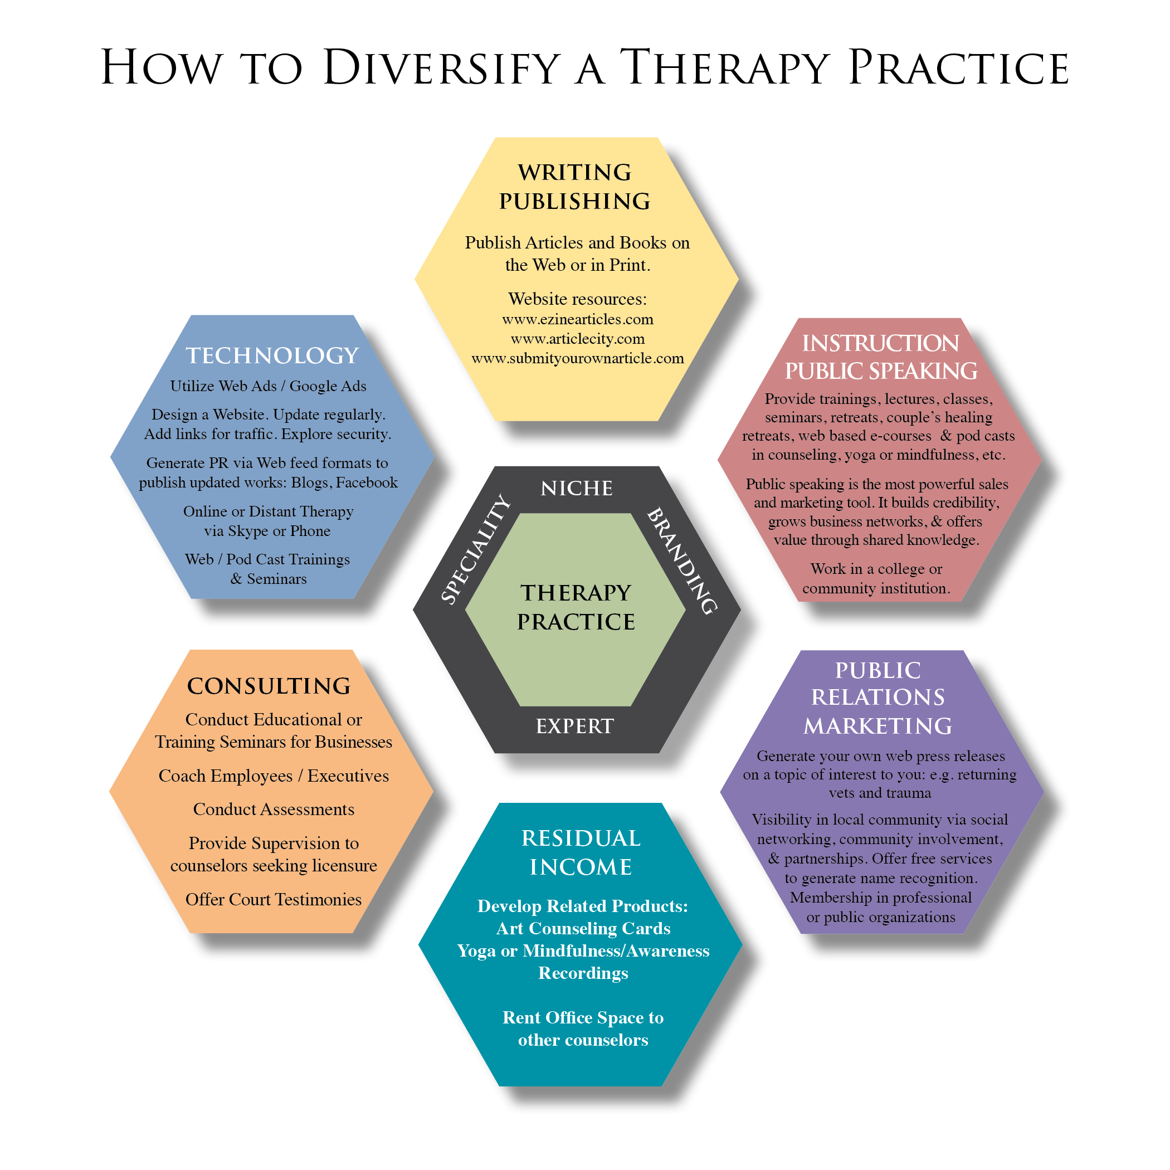
Effective marketing builds relationships and engages community. It offers trust, builds awareness and increases credibility. Diana recommends finding opportunities to showcase your knowledge and expertise. In order to accomplish this Diana says a “sales progression” is not only effective, but essential. He articulates that marketing one’s profession is not in conflict with therapeutic values. “Professionals need to explore directly and without apologies: aspects such as career growth and advancement, competitive advantages and differentiation in the marketplace, and financial success for the practitioner.” (2005, pg. 3). The five-step sales progression he suggests is: 1.) Build trust through offering something of value and demonstrating you are highly skilled; 2.) Once trust is established inspire the consumer to take action i.e. signing up for your email list; 3.) Reward the action by emailing a resource in return without a sales pitch; 4.) this further builds trust 5.) which can lead to word of mouth advertising and credibility for paid services such as seminars, individual counseling, job opportunities, etc.
Using one’s talents, knowledge, and passions effectively, help not only the practitioner but also those who benefit from their services. This creative approach inspires individuals to expand their definitions of career, creating more satisfying professions and integrated lives.
Section IV: Web Techology and Marketing Services
Greatly influenced by today’s technological advancements, there are many possibilities for helping professionals to set up a private practice. A variety of avenues are accessible to counselors who want to increase their visibility and availability to prospective clients in search of therapeutic support. Professional websites and pay-per-click advertising are two valuable tools practitioners can use to expand their client base by providing information about themselves and their services.
Creating a professional website gives counselors a way to establish a web presence, allowing web users to get to know them better and become clients (Truffo, 2007, p.44). Although creating a website might seem like a monumental task, there are some companies like lunarpages.com who offer templates that allow customers to fill in the blanks, and create a website by clicking buttons (2007, p.44). Utilizing a website allows counselors an opportunity to share their expertise and personal information, making it easier for clients to arrive at an informed decision. When creating a website, Truffo suggests using headlines that speak to your clients’ concerns: “Parenting a teen can be a very tough job” shows the client you know what they are going through (2007, p.44). A website also gives counselors an opportunity to market articles and books as well as audio and video content that are pertinent to the prospective clients’ needs. Counselors can create links to their websites by using internet advertising which increases the amount of website exposure.
Pay-Per-Click Ads are one method used by professionals to increase the visibility of their websites. Facebook, for example, sells ads on the web which may be directed to potential clients based on location, age and interest. Counselors can choose specific terms they believe their potential clients may be searching for and pay a bid amount for each search term. (Truffo, 2007, p.43). Each time someone clicks on your ad you are charged the chosen bid amount and the customer is immediately redirected to your website. Facebook offers the potential to connect advertisers with up to five hundred million customers, greatly enhancing your online visibility. The use of this technology enhances and broadens one’s client base.
Another way practitioners are using technological applications to broaden client base is through video teleconferencing. “Video teleconferencing allows participants to conduct visually interactive electronic meetings between one or more distant locations using video cameras, monitors, and communications. VTC can be a possible solution to limited rural mental health services” (Jerome & Zaylor, 2000), which can greatly increase the variety of therapeutic interventions available to those who would not otherwise have access. Those in rural areas will have greater options for the specific style of counseling they prefer along with more opportunities to access counselors with appropriate credentials. In addition to expanding geographic boundaries, VTC decreases the cost and time associated with travel, a benefit for both the counselor and client. Counselors can utilize saved travel time, counseling additional clients which would, in turn, have a positive effect on net income. While VTC provides clients with the comfort and safety of their own home, practitioners benefit by counseling from their homes, decreasing the high costs often associated with office rental.
The utilization of these advancements gives the counselor more marketing tools to broaden the client base. These technological implements provide both the counselor and client with convenient and money saving options that reach far beyond the counseling office chair.
Section V: Technology for Service Delivery

For a successful practice, mental health therapists need to adopt a “small business entrepreneur” mind frame exploring alternative methods of earning. Technological tools offer new avenues of service delivery, advertising, and marketing. “The spread of telecommunication technologies provide mental and behavioral health care with exciting opportunities in research, teaching, practice, and overall delivery of care” (Maheu et al, 2005, p.3). A technological explosion of mental health practices has resulted in the definition of new terms such as “psychotechnologies” that include e-counseling, cybercounseling, cybertherapy, teletherapy, telemental health, telepsychiatry, e-therapy and behavioral e-care” (Maheu et al, 2005, p.9) Psychothechnologies can be deployed “on a global scale in war-torn areas” (Maheu et al, 2005, p.10) and can be offered in “rural clinics, military programs, correctional facilities, community mental health centers, nursing homes, home health care settings, and hospitals. Psychothechnologies offer new perspectives and possibilities such as reducing stigma associated with mental health by providing education, increasing public knowledge, and improving mental health delivery by making treatment more accessible and affordable (Maheu et al, 2005, p.11). Advanced internet technologies are becoming widely used by the general public. Additional requirements for mental health professionals are necessary in order to keep up with technology and get familiar with the right equipment for confidential communication systems.
Mental health professional online presence can influence “one’s reputation” and capabilities to deliver services, building a professional image that will distinguish them from many other “commercial enterprises and self-appointed healers” (Maheu et al, 2005, p.53). According to Maheu et al, in 2001, 42% of physicians were working in practices with Web sites while today’s majority of large mental health agencies maintain a Web site (Maheu et al, 2005, p.79). Alongside bulletin boards, emails, newsgroups, internet chats, email forums, internet development allows practitioners to build their web sites which become virtual offices in need of their personal touch. Maheu et al, state “health care consumers are seeking in-depth information on a specific subject.” Mental health practitioners who use technology to add value and their professional expertise are more likely to achieve a long-term success. Web site development should be approached with this final goal in mind (Maheu et al, 2005, p.80).
Protection of the client’s privacy and confidentiality is important and special attention must be paid to the protection of the client’s information. Even a single security breach can seriously compromise a therapists’ reputation (Maheu et al, 2005, p.84). While creating one’s own Web sites is a possibility, Dr. Maheu suggests that hiring a professional Web designer is highly recommended for the best results (Maheu et al, 2005, p.90). While building a successful Web site has endless possibilities, the end goal is to “integrate a Web presence with an existing mental health practice or a mental health association’s mission” (Maheu et al, 2005, p.79).
Services such as telephone and voice mail have been used for initial contacts, screening, scheduling sessions, and making referrals. To date “interactive videoconferencing is the preferred technology for direct care of patients by licensed health care practitioners in all aspects of health care, including mental health” (Maheu et al, 2005, p.113). Even though the research indicates that therapy delivered by telephone and videoconferencing is “efficacious” it is not the preferred method of electronically mediated therapy. Common barriers to using telephone and videoconferencing include a clinician’s approach for managing emergencies from a distance, interstate and international practice and licensure laws and regulations, privacy, security, confidentiality with telecommunications, handling of electronic medical records, and the reliability, affordability and compatibility of technologies (Maheu et al, 2005, p.120). Another factor is lack of full video capability due to the cost. Whiteboards, an online tool, may be used in combination with videoconferencing providing the same function as “schoolroom’s chalkboards (Maheu et al, 2005, p.137). When making decisions for conducting distance therapy, important factors of reliability, efficacy, and evidence-based treatment methods should be considered for the targeted population.
While the videoconference is still pending HIPAA approval, the area with the greatest potential for expansion are self-instructional programs that can be used as valuable additions to psychotherapy and psychoeducation. Starting in1980, psychoeducational programs were designed to prevent “dysfunctional health-related behaviors or promote positive health behavior” (Maheu et al, 2005, p.179). These computer-assisted programs include drug and alcohol abuse prevention, promotion of responsible sexual behavior, enhancement of self-esteem, managing stress and anxiety, confronting phobias, and therapeutic learning programs designed to “help clients counter self-doubts that interfere with personal development”(Maheu et al, 2005, p.179). Additionally, computer games have been developed to assist children and adults to control impulsivity, behavioral problems, and restore sensory motor functional deficits after traumatic brain injuries (Maheu et al, 2005, p.185). With technology advancements, programs are being developed for handheld portable devices that can assist with treatment beyond the therapy hour. Biofeedback devices have been used for psychophysiology, which electronically measure interactions between a person’s physiological functions while thinking about traumatic events or listening to soft music (Maheu et al, 2005, p.191). Biofeedback devices measure heart rate, respiration, skin conductance, muscular activity and finger temperature allowing the therapist to read the measurements and assist clients in altering cognitive, emotional, and/or physiological behavior (Maheu et al, 2005, p.191).
Advancement of technology allows the use of virtual reality assisted therapy for assessment and treatment of phobias, anxiety, perceived body image, pain reduction and distraction. A research program at Stanford tests “the feasibility and effectiveness of bringing online clinical practice to schools” in order to prevent eating disorders by educating students about healthy life choices and “cognitive intervention to counteract media driven weight concerns” (Maheu et al, 2005, p.195). The American Foundation for Suicide Prevention developed initiatives to provide web services that assess students for suicide risk, pointing them to “in-person professional evaluation and support” (Maheu et al, 2005, p.196).
Computerized therapeutic programs, games, virtual reality, biofeedback, and specialized Web sites are available to therapists to enhance their everyday practice. Objective data, reliably, and efficiency measures are necessary tools needed to determine therapeutic progress when therapy is conducted at a distance.

SectionVI: Summary Conclusion?

The benefits for growing a successful private practice can be exponential. Bavonese (2007) and Grodski (2007, 2009) point out that business expanding can result in more clients benefitting from the extensive training and skills that a therapist has to offer. Additionally, as counselors grow their business, they can often also begin to refer to other clinicians or employ additional staff including other therapists.
The process of becoming a business savvy therapist can be an exciting one. Developing a brand for ones practice can deepen one’s clinical expertise. Diversifying ones services can increase clients’ options as well as developing multiple streams of income. Taking advantage of new technologies, cannot only be profitable and effective, but also keeps counselors current in the professional technologies used in the multiple industries that their clients inhabit.
To be successful in private practice, counselors need to know honor their personality type, which will determine to “structure your marketing and business time” (Earle & Barnes, 1999, p.3). In order to succeed, one’s private practice must reflect one’s values, beliefs, personality and goals (Earle & Barnes, 1999, p.10). Graduate school and experience obtained through internship usually are not sufficient to prepare a therapist for marketing a private practice and the shift in thinking about oneself as a business person as well as a therapist. (Earle & Barnes, 1999, p.27). The key focus for successful practice is the process of educating individuals and community about what is one’s area of expertise.

Section VII: Reference List

American Counseling Association (ACA). http://www.counseling.org/
Bavonese, J., (2007, July/August). How to develop a money mindset: Investing for success in your therapy business. Psychotherapy Networker, 33-39,56.
Castelnuovo, G., Gaggioli, A., Montovani, F. & Giuseppe,R. (2002). New and old tools in psychotherapy: the use of technology for the integration of traditional clinical treatments, treatments. Psychotherapy: Theory, Research, Practice, Training. Vol.40 , 33-44.
Council of the Accreditation of Counseling and Related Educational Programs (CACREP). www.CACREP.org
Diana, D. P. (2010) Marketing for the mental health professional: An innovative guide
for practitioners. Hoboken, NJ: John Wiley and Sons, Inc.
Earle, H.R., Barnes, J.D. (1999). Independent practice for the mental health professional: growing a private practice for the 21st century. Brunner/Mazel, Taylor & Francis Group.
Feller, R.W. and Whichard, J. (2005). Knowledge nomads and the nervously employed:
Workplace change and courageous career choices. Austin, TX: Pro-ED.
Grodzki, L., (2009, March/ April). Recession proof your practice: Review, recommit, rebrand, reinvest. Psychotherapy Networker, 34-39.
Grodzki, L., (2007, July/August). The Winds of Change. Psychotherapy Networker, 25-31.
Maheu, M.M., Pulier, L.M., Wilhelm, H.F., McMenamin, P.J., Brown-Connolly, E.N. (2005). The mental health professional and the new technologies: a handbook for practice today. 1st ed. Lawrence Erlbaum Associates, publishers. Mahwah, New Jersey, London.
Truffo, C. (2007, July/August) Beyond technophobia. Psychotherapy Networker, 42-47.

Walsh, R.J., & Dasenbrook,N.C., (1/05/2005). Starting a Private Practice. Retrieved from www on November 27, 2010. www.counseling.org/Counselors/TP/PrivatePracticePointersMembers.
Walsh, R.J., & Dasenbrook,N.C., (7/2008). Starting a Private Practice from Scratch Podcast. Retrieved from WWW on November 27, 2010. www.counseling.org/Counselors/TP/PodcastsMembers

